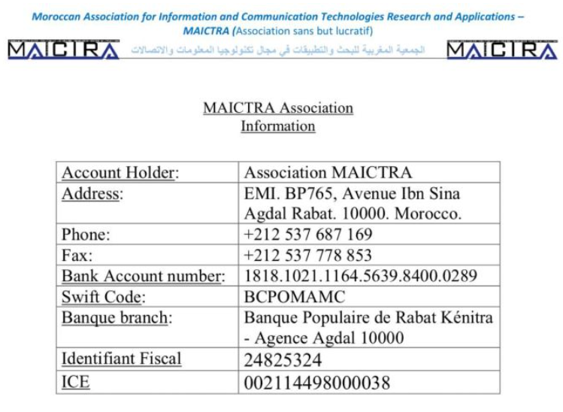

**Registration form**

(Please fill in this registration form and send it with the payment confirmation to: conferencecistem2024@ensam.um5.ac.ma)

Title (Mr. / Mrs.): ......... First Name: ......................................... Last Name: ……………….……..............................

Paper ID: ……………..................................................................................................…………………………………………

University/Company: ………………………………………………………………………………………………………………………..…………

Country: .................................Phone: ....................................... E-mail:......................................................……

Registration fees:(include attendance to all scientific sessions, coffee breaks, lunches, social events, and publications of

the registered papers in Scopus journals)

Please mention the amount due:

|  |  |
| --- | --- |
| **Student registration fees: student from a University in Maghreb**  **1050 MDH / 105 €** | ………………. |
| **Regular registration fees: Researcher, Professor, Industrial from a University in Maghreb**  **1550 MDH / 155 €** | ………………. |
| **Student registration fees: Student from a university outside Maghreb**  **270 €** | ………………. |
| **Regular registration fees: Researcher, Professor, Industrial from a University outside Maghreb**  **320 €** | ………………. |

**Payment method**

Payment is possible by bank transfer. Registration fee should be transferred to the MAICTRA association bank account. Please use the bank account information given below. **The bank transfer order should be sent with the reference "CISTEM2024". The bank transfer order should be scanned and sent by e-mail to**: conferencecistem2024@ensam.um5.ac.ma.

**5th International Conference on Electrical Sciences and Technologies in Maghreb CISTEM 2024**

**30 October to 01 November 2024, Rabat, Morocco**

**Web site: https://cistem2024.sciencesconf.org/**